ARCHITECTURE DOCUMENT
Vimal M & Alfred Ferdinand

Project Title
An Integrated Explainable AI (XAI) Framework for Early Risk Assessment of Lifestyle-Induced Non-Communicable Diseases via Multimodal Data Fusion

1. ARCHITECTURE SELECTION
Selected Architecture Type
✅ Monolithic Architecture (Layered & Modular)
Other Architectures Considered
- Microservices
- Event-Driven Architecture
- Serverless Architecture
Justification for Choosing Monolithic Architecture
The proposed system is a research-oriented academic project focused on feasibility validation, explainability, and experimentation rather than large-scale deployment. Hence, a layered monolithic architecture is selected for the following reasons:
- Simplifies experimentation and debugging
- Ensures reproducibility of machine learning results
- Reduces operational complexity for academic research
- Enables faster iteration during limited semester timelines
- Supports logical modularization while remaining a single deployable unit
Although implemented as a monolithic system, the architecture follows strict modular separation, making it extensible to microservices in future work.

2. HIGH-LEVEL ARCHITECTURE OVERVIEW
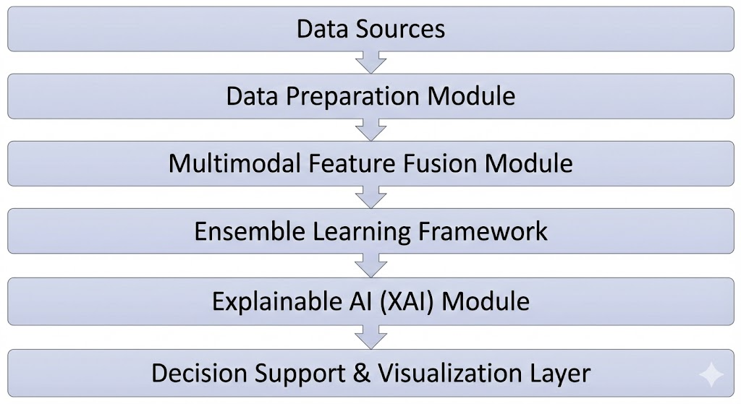
The system is organized into six logical layers:
- Data Sources
- Data Preparation Module
- Multimodal Feature Fusion Module
- Ensemble Learning Framework
- Explainable AI (XAI) Module
- Decision Support & Visualization Layer
This architecture is illustrated in Figure 1 (High-Level Architecture Diagram).

3. HIGH-LEVEL ARCHITECTURE DESCRIPTION (HLD)
3.1 Data Sources
- BRFSS 2015 Dataset
- Chronic Kidney Disease Dataset (UCI)
- Indian Liver Patient Dataset (UCI)
These datasets provide lifestyle, behavioral, demographic, and clinical features.

3.2 Data Preparation Module
Responsible for:
- Data cleaning
- Missing value imputation
- Categorical encoding
- Feature scaling and normalization
Ensures consistency across heterogeneous datasets.

3.3 Multimodal Feature Fusion Module
- Aligns lifestyle and clinical features
- Handles dataset-specific feature mappings
- Produces unified feature vectors

3.4 Ensemble Learning Framework
Consists of:
- XGBoost
- Random Forest
- Logistic Regression
Predictions are combined using weighted soft voting to improve robustness and generalization.

3.5 Explainable AI (XAI) Module
- Uses SHAP (SHapley Additive exPlanations)
- Provides instance-level feature attribution
- Improves transparency and trust

3.6 Decision Support & Visualization Layer
- Displays disease risk scores
- Visualizes SHAP explanations
- Supports interpretability and analysis

4. LOW-LEVEL ARCHITECTURE (LLD)
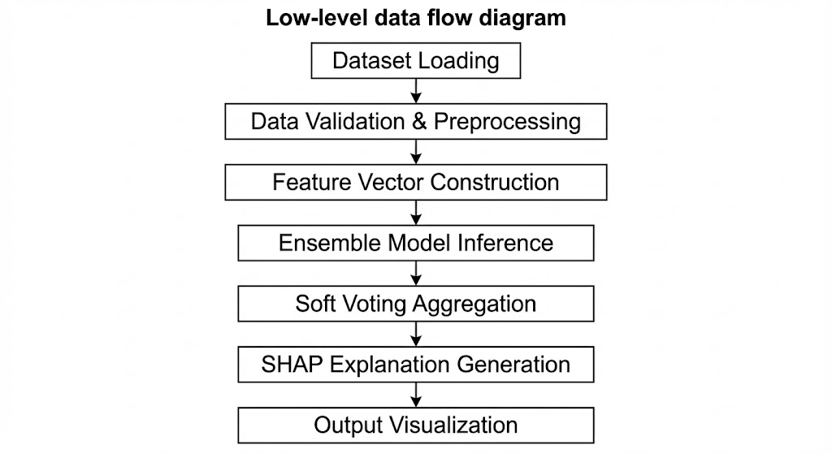
The Low-Level Design defines:
- Module interactions
- Data flow
- Input/output relationships
Mapped to Figure 2 (Low-Level Data Flow Diagram).
Low-Level Flow Summary
- Dataset loading
- Data validation & preprocessing
- Feature vector construction
- Ensemble model inference
- Soft voting aggregation
- SHAP explanation generation
- Output visualization

5. USE CASE DIAGRAM DESCRIPTION
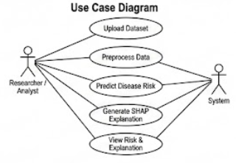
Actors
- Researcher / Analyst
- System
Use Cases
- Upload Dataset
- Preprocess Data
- Predict Disease Risk
- Generate SHAP Explanation
- View Risk & Explanation
Purpose:
Defines user interaction with the system from a functional perspective.

6. CLASS DIAGRAM DESCRIPTION
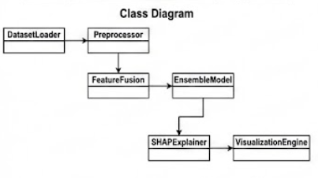
Key Classes
- DatasetLoader
- Preprocessor
- FeatureFusion
- EnsembleModel
- SHAPExplainer
- VisualizationEngine
Relationships
- DatasetLoader → Preprocessor
- Preprocessor → FeatureFusion
- FeatureFusion → EnsembleModel
- EnsembleModel → SHAPExplainer
- SHAPExplainer → VisualizationEngine

7. DATA FLOW DIAGRAM (DFD) DESCRIPTION
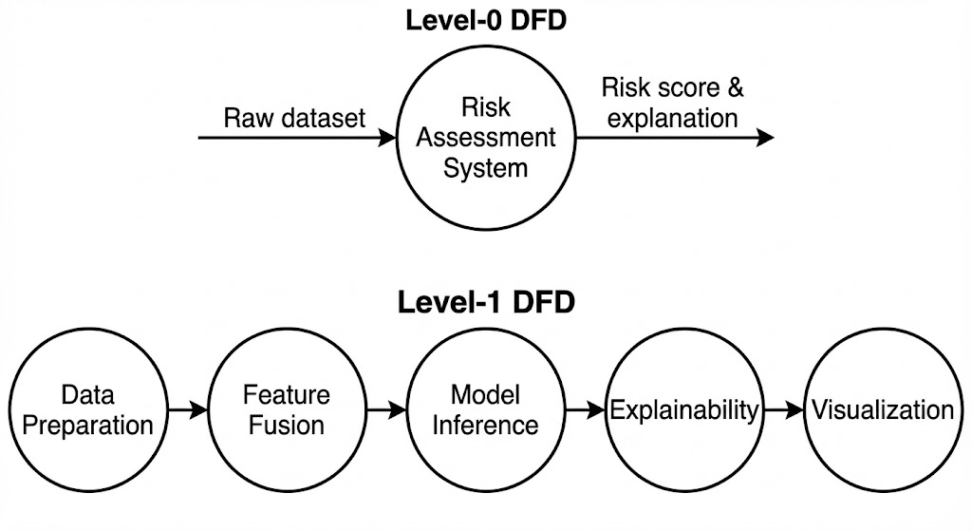
Level-0 DFD
- Input: Raw dataset
- Process: Risk Assessment System
- Output: Risk score & explanation
Level-1 DFD
- Data Preparation
- Feature Fusion
- Model Inference
- Explainability
- Visualization

8. COMPONENT DIAGRAM DESCRIPTION
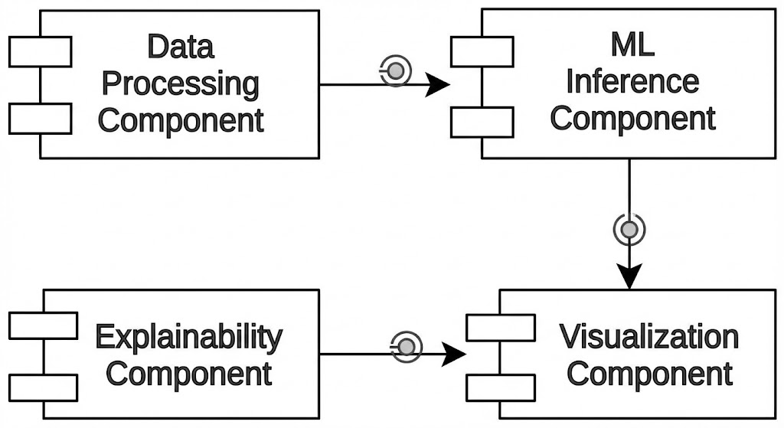
Major Components
- Data Processing Component
- ML Inference Component
- Explainability Component
- Visualization Component
Each component interacts through defined interfaces and data contracts.

9. SEQUENCE DIAGRAM DESCRIPTION
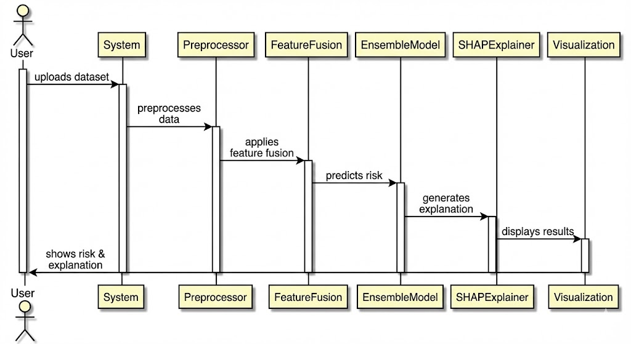
Sequence Flow
- User uploads dataset
- System preprocesses data
- Feature fusion is applied
- Ensemble model predicts risk
- SHAP generates explanation
- Results are displayed
Shows time-ordered interaction between system components.

10. DEPLOYMENT DIAGRAM DESCRIPTION
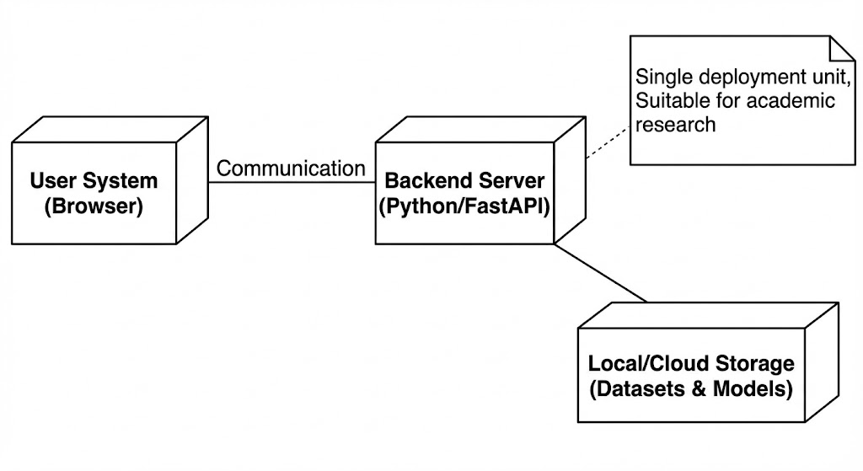
Deployment Environment
- User System (Browser)
- Backend Server (Python/FastAPI)
- Local/Cloud Storage (Datasets & Models)
Deployment Characteristics
- Single deployment unit
- Local or cloud-based execution
- Suitable for academic research

11. TECHNOLOGY STACK
Layer | Technology
Data Processing | Python, Pandas, NumPy
Machine Learning | XGBoost, Random Forest, Logistic Regression
Explainability | SHAP
Backend | FastAPI
Frontend | Next.js, Tailwind CSS
Visualization | Recharts

12. ARCHITECTURAL JUSTIFICATION
- Monolithic architecture simplifies research execution
- Layered modularity ensures clarity and maintainability
- Explainability-first design ensures trust
- Framework-based approach avoids disease-specific silos

13. CONCLUSION
The selected monolithic layered architecture provides a robust, explainable, and scalable foundation for early risk assessment of lifestyle-induced non-communicable diseases. The architecture satisfies all academic requirements, supports phased implementation, and aligns with SRM’s expectations for research-oriented projects.

